Eventi
Use Case Diagram

Submitted to:

Prof. Ma. Rowena C. Solamo
Faculty Member
Department of Computer Science
College of Engineering
University of the Philippines, Diliman

Submitted by:
Dimaano, Aaron Diego I.
Lopez, Matthew S.
Torres, Jacob Angelo V.

In partial fulfillment of Academic Requirements
for the course
CS 191 Software Engineering I
of the
1st Semester, AY 2014-2015
Unique Reference:
The documents are stored in this repository: https://github.com/Tom-2013-06417/CS191-192_Event_Sharing.
Link to this document: https://github.com/Tom-2013-06417/CS191-192_Event_Sharing/blob/master/02-Requirements%20Engineering/Eventi%20-%20Use%20Case%20Model.pdf.

Document Purpose:
The purpose of this document is to further conceptualize how the users are to interact with the software by means of a UML User Case Model diagram. Through the diagram, the actors and their specific tasks are specified in terms of a high-level overview.

Target Audience:
To our project client and adviser, our fellow 191 classmates, and our future selves when they need to refer back to this document.

Revision Control

Revision Date | Person Responsible | Version  Number | Modification
09/18/15 | Diego Dimaano  Matthew Lopez  Jacob Torres | 1.0 | Initial Document.

System Name: Eventi

Description:
Eventi is a website that aims to centralize all general events within the university and therefore providing a platform for those who seek publicity for their event as well as for those who want a single go-to site containing for everything they need to know about the events in UP.

Use-Case Diagram:
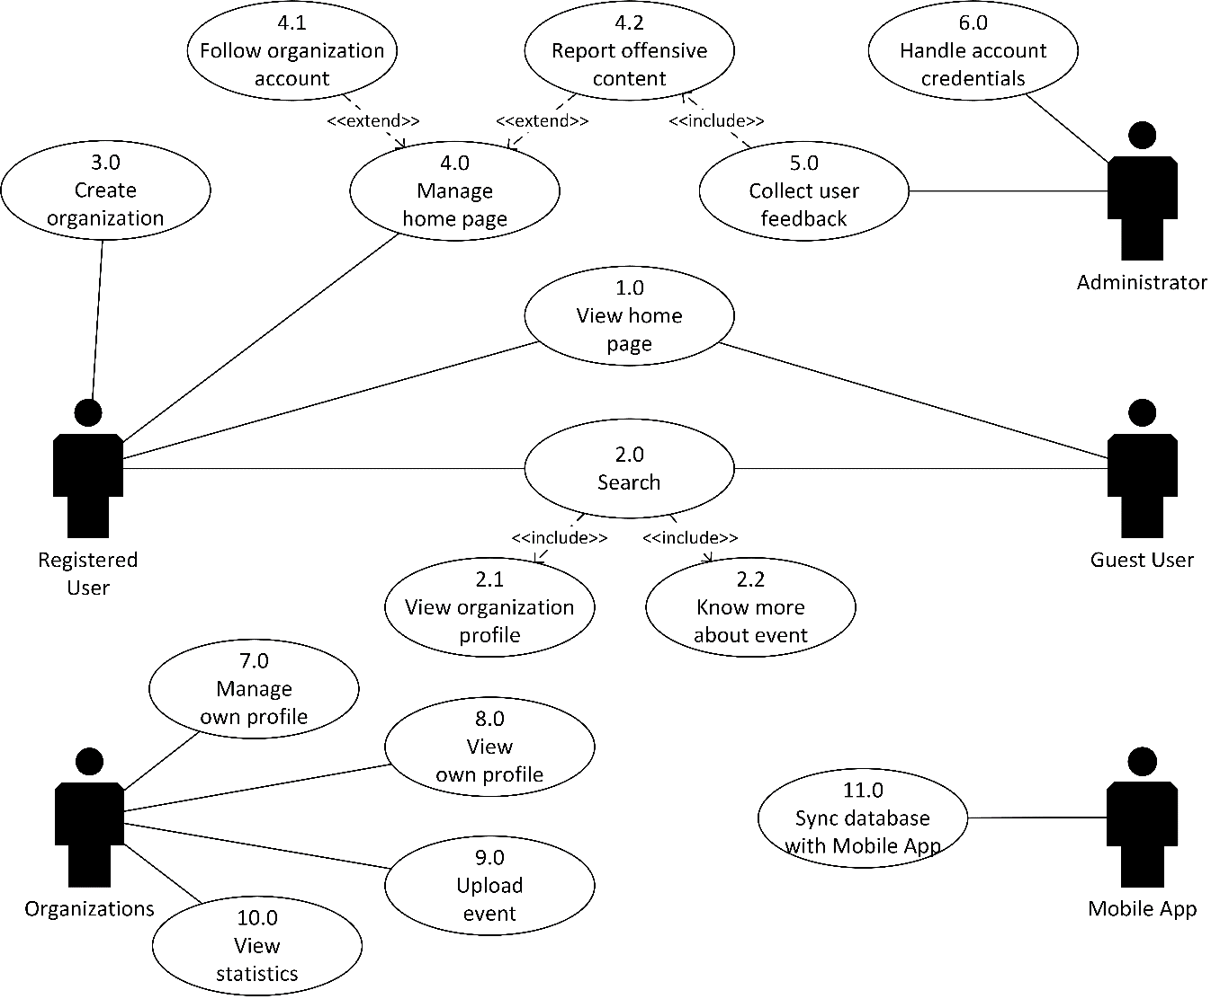

List of Actors:

Actors | Description
Registered User | These actors are users with Eventi accounts. They are the ones responsible for posting and managing events. They also possess heightened features that differ from Guest Users.
Organizations | These entities would serve as the medium for Registered Users to post events under the name of an organization. The Users would post their events through here for the Guest User to see. It is similar to Pages in Facebook.
Guest User | All newcomers of Eventi are classified as Guest Users. These actors are the non-registered, free roaming users of Eventi. Their only purpose is to search and view the posted events. They can upgrade to be a Registered User.
Mobile App | This is the external entity. It would be in sync with the website and the databases in real time. This is basically the link between the two systems. The other way around also applies (App to Website).

List of Use-cases:

Use-Case | Description
Use-Case 1.0 View home page | This is the first page a user sees after loading the Eventi website. Displayed in the home page are the different events ranging in various tiles depending on popularity. Everyone is a Guest User unless they register and log in the site.
Use-Case 2.0 Search | The Eventi system’s main feature is search. The search function would be acted by both Guest and Registered Users. The function would include tags and filters as to limit search queries and display the most relevant answers.
Use-Case 2.1 View organization profile | This is a fundamental operation of any Eventi user. As the search results are displayed
Use-Case 2.2 Know more about event
Use-Case 3.0 Create organization
Use-Case 4.0 Manage home page
Use-Case 4.1 Follow organization account
Use-Case 4.2 Report offensive content
Use-Case 5.0 Collect user feedback
Use-Case 6.0 Handle account credentials
Use-Case 7.0 Manage own profile
Use-Case 8.0 View own profile
Use-Case 9.0 Upload event
Use-Case 10.0 View statistics
Use-Case 11.0 Sync database with Mobile App

